BE Metrics and Management – Internal APIs

Ashwin Jayaprakash
Mar 2009

Advertisement of metrics and management capabilities

Each Agent publishes 2 basic types of information:
- Management
- Metrics

Management:
Announces the Agent’s basic contact information like:
- Agent names
- IP Address
- Management port and other information
- List of metrics and their data definitions
  - Some families of metrics are only available at runtime. However their basic structure/data definition will be common

Code/API:
ManagementTable
MetricTable

Domain
DomainKey
MetricDef
DataDef
Data

CoherenceAdapter

Publication of metric definitions and metrics

Each metric is a fully qualified name. All metrics from all the agents are stored in a single Coherence Cache. This cache only holds the most recent information for each metric.

Coherence APIs should be used to list down all the metrics that are available. Listeners should also be registered to listen to new metrics that get added.

MetricDefs:

Each Metric family has an associated MetricDef associated with it.

Inference Engine metrics are described below:
- Per channel TPS and latency
- Rule Function and Rule TPS and latency (Dynamic)
- Post RTC TPS and latency
- Lock acquisitions per second
- All asynchronous worker thread counts and statuses, job queue lengths

MetricDef Name | DataDef
%clusterName%.%processId%.AsyncWorkerDataPublisher.%asyncWorkerName%
  Column name | Column data type
  maxThreads | Integer
  activeThreads | Integer
  queueCapacity | Integer
  queueSize | Integer
  timeMillis | Long
%clusterName%.%processId%.%agentName%.%agentId%.RtcTransactionPublisher
  Name | Type
  startTimeMillis | Long
  endTimeMillis | Long
  count | Long
  avgTxnMillis | Double
  newOrUpdate | Boolean
%clusterName%..%processId%.%agentName%.%agentId%.InferenceAgent.%inReteCall%
  Name | Type
  startTimeMillis | Long
  endTimeMillis | Long
  count | Long
  avgTxnMillis | Double
  newOrUpdate | Boolean
%clusterName%.%processId%.LockManager
  Name | Type
  startTimeMillis | Long
  endTimeMillis | Long
  count | Long
  newOrUpdate | Boolean

Accessing metrics

Coherence Listener API should be used listen to the updates for each metric.

Analyzing metrics

Raw metrics are to be obtained from the Cache. A custom BE project will be created to analyze these metrics.

Custom BE Project:

A BE project will be created to host the logic that will analyze and perform post-processing of the raw metrics.

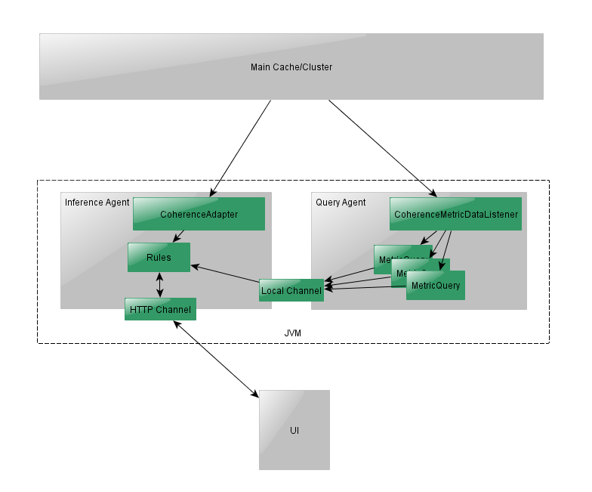

Agents:
This project will contain a Query Agent and other HTTP and TCP Channels to handle requests from end-user clients – as a Presentation server.
An Inference Agent might also be required to handle user requests and also for alerting rules etc.

Project Ontology:
The Query Agent will listen to changes in the Metric Table and consume the raw metric data. Since there is not BE Ontology associated with the metric data, custom listener code will be created to listen to the direct Tangosol NamedCache and will serve as an Adapter. The project will have a BE Ontology that reflects the raw metric structure. This will have to be defined in advance.

When a raw metric event is published on to the Cluster, the adapter will convert it into the BE Ontology Event and convey it to the Query Agent.

Since default Query Agents that come with BE can only listen to Ontology changes from the Cache, it cannot be used directly and will need customization.

The project has a fixed Ontology that reflects the metric data. This Ontology is not the same as project that is being profiled. BE does not permit 2 separate Ontologies in the same Cache cluster. So, the Profiler project’s Ontology has to be separate or private. Hence this project requires customization.

Properties to be enabled on the Query Agent to listen to metric events from the main Cluster:
be.agent.query.querydataprovider.classname=com.tibco.cep.query.stream.impl.rete.integ.metrics.CoherenceMetricDataListener

be.agent.query.querydataprovider.metricobjecttransformer.classname=com.tibco.cep.query.stream.impl.rete.integ.metrics.DefaultMetricObjectTransformer

be.metric.cluster.property.tangosol.coherence.localhost=localhost
be.metric.cluster.property.tangosol.coherence.localport=9901
be.metric.cluster.property.tangosol.coherence.clustername=darknet
be.metric.cluster.property.tangosol.coherence.cluster=darknet
be.metric.cluster.property.tangosol.coherence.clusteraddress=224.3.3.6
be.metric.cluster.property.tangosol.coherence.clusterport=3333
be.metric.cluster.property.tangosol.coherence.ttl=0

Optionally, if WKA is to be used, then:
be.metric.cluster.property.tangosol.coherence.wka=198.163.10.3
be.metric.cluster.property.tangosol.coherence.wka.port=8700

Continuous Queries:

Per channel TPS and latency:
(Select top 3 channel metrics, sorted on average count and then latency over the last 15 minutes)
select channel.agentId, channel.name, avg(channel.count) as avgC, avg(channel.latency) as avgL
from /Metric/ChannelMetric {policy: maintain last 15 minutes by agentId, name; accept: new} as channel
group by channel.agentId, channel.name
order by avgC desc {limit: first 3}, avgL desc {limit: first 3}

Rule Function and Rule TPS and latency (Dynamic):
(Select top 15 calls made inside Rete, sorted on average count and then latency over the last 15 minutes)
select inReteCall.agentId, inReteCall.name, avg(inReteCall.count) as avgC, avg(inReteCall.latency) as avgL
from /Metric/ReteMetric {policy: maintain last 15 minutes by agentId, name; accept: new} as inReteCall
group by inReteCall.agentId, inReteCall.name
order by avgC desc {limit: first 15}, avgL desc {limit: first 15}

Post RTC TPS and latency:
(Select top 3 PostRTC metrics, sorted on average count and then latency over the last 15 minutes)
select postRete.agentId, avg(postRete.count) as avgC, avg(postRete.latency) as avgL
from /Metric/PostReteMetric {policy: maintain last 15 minutes by agentId; accept: new} as postRete
group by postRete.agentId
order by avgC desc {limit: first 3}, avgL desc {limit: first 3}

Lock acquisition rate:
(Select top 3 Agents whose lock acquisitions are high over the last 15 minutes)
select lock.agentId, avg(lock.count) as avgC
from /Metric/LockMetric {policy: maintain last 15 minutes by agentId; accept: new} as lock
group by lock.agentId
order by avgC desc {limit: first 3}

Asynchronous worker threads and queue sizes:
(Select Agents with their current thread counts and job queue sizes)
select service.agentId, service.name,
service.maxThreads, service.activeThreads,
service.maxQueueSize, service.currentQueueSize
from /Metric/AsyncServiceMetric {policy: maintain last 10 tumbling; accept: new} as service
order by service.activeThreads desc, service.currentQueueSize desc

Displaying metrics

Sample Graphs:

In addition to showing the top X objects as measured by the Queries, some additional graphs may be useful.

Time series graphs showing Latency vs Count for Channels and PostRTC:
(Needs 2 Y axes for Latency and Count)
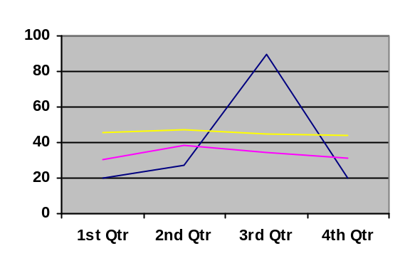

Lock Acquisition rate graph and Asynchronous worker stats:
